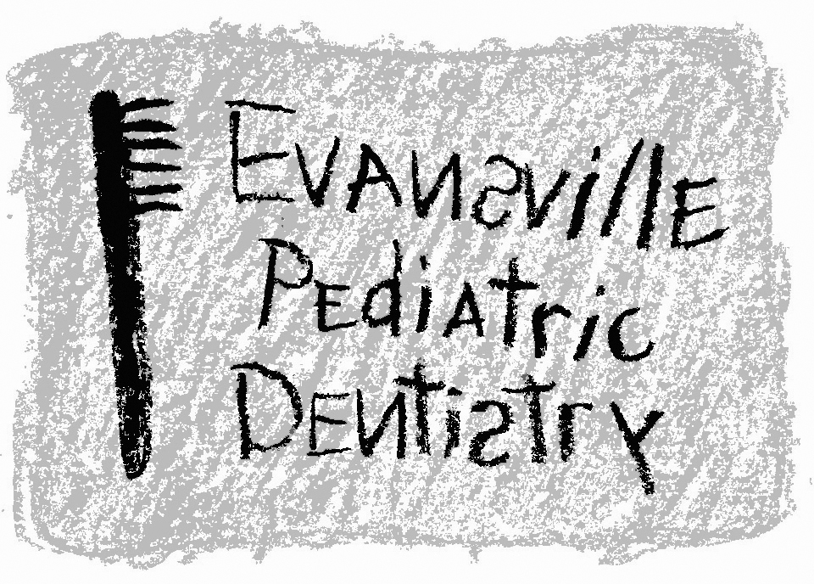
Jeffrey A. Hiester, D.D.S.
EAST WEST
7200 E. Virginia Street 2345 W. Franklin Street #101
Evansville, IN 47715 Evansville, IN 47712
(812) 479-8609 (812) 401-6095

Consent for Conscious Sedation

Patient’s Name _____________________________________ Date of Birth ________________

I hereby authorize Dr. Jeff Hiester to perform necessary dental treatment on my child/legal ward utilizing conscious sedation techniques including the usage of a papoose board to minimize the movements of my child/legal ward. I understand that my child is either unable to be treated in a cooperative patient/doctor setting using usual and customary dental techniques or the procedure requires the need for conscious sedation. The purpose and nature of the need for conscious sedation has been fully explained to me.

I fully understand there is a possibility of surgical and/or medial complications developing during or after the procedure. These risks and side effects may include adverse reaction to a drug or a typical psychological response that may even cause hospitalization, further surgical procedures, disability, and system impairment, permanent or temporary nerve damage, brain damage or death. I further authorize Dr. Jeffrey A. Hiester, D.D.S. to perform treatment as may be advisable to preserve the health and life of my child or legal ward.

I understand that sedation may prove partially or completely ineffective in managing my child or legal ward. In such an instance the planned treatment may not be possible or may require several appointments using these conscious sedation techniques to complete the necessary dental work and/or an alternative treatment may be instituted.

I have been provided with an explanation of alternatives to treatment and understand the risks of not being treated for the dental condition.

I have carefully read the above and in addition have had all of my questions in regard to sedation to be administered, the outlined risks, and side effects answered.

I do give my free and voluntary informed consent to the same.

Date _____________________________________ Time _______________________________

Signature _________________________________ Relationship _________________________

Signature of Doctor ______________________________________________________________

I have been given an estimate of the cost of my child’s needed dental treatment. Fees and procedures have been explained to me. I understand that the fees for sedation will be billed and payable on the day of the appointment even if the sedation proves partially or completely ineffective.

Signature _______________________________________________ Date __________________

